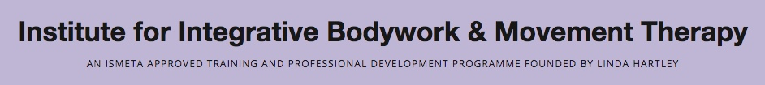

**IBMT Module Application Form**

*Please complete both pages*

**Name of Module:**

**Name:**

**Pronouns:**

**Address:**

**Telephone:**

**Mobile:**

**E-mail:**

**Date of payment of non-refundable Application Fee:**

**Tick / indicate you are attaching a Photo with your application:**

**Tick / indicate that you are attaching your Letter of Recommendation (see over):**

*In completing this form you are giving your consent to my information being stored on the IBMT database. Further details can be seen in our* [*Privacy Policy*](http://ibmt.co.uk/privacy-policy/)*.*

If you are applying for your first module with IBMT please make your non-refundable Application Fee payment. £50 for applications received 6 weeks before the start of the module. Late application fee of £85 in the 6 weeks before the start of the module.

**Payment information:**

**On-line:**

Account Name: IBMT Administration

Account Number: 28976868 Sort code: 30 90 39

IBAN (International Bank Account Number): GB84 LOYD 3090 3928 9768 68

Lloyds Bank BIC (Branch Identifier Code): LOYDGB21135

* Please use “Application and Your Name” as a reference and send an email to info@ibmt.co.uk giving details of the payment you have arranged.

**Payments from Non-UK, Non-Sterling Accounts:**

We recommend payment via [wise.com](https://wise.com/). Please ensure we receive payment in Pounds.

For a video about setting up an account with wise: <https://www.youtube.com/watch?v=qGmRv9SMxFw>

For a video about sending money abroad with wise: <https://www.youtube.com/watch?v=IZtLF0nhqFc>

* If you make a bank transfer, please make sure that all transfer costs are covered, and the exact amount in £ sterling will be received (IF YOU ARE PAYING FROM A NON-UK ACCOUNT please add an additional bank charge of £7 to all payments over £100, £2 to all payments under £100).

Please let us have details of the following:

1. Where did you hear about IBMT?
2. Is it your intention to complete the whole diploma or an individual module?
3. How do you meet the module pre-requisites (these are listed on the module page of the website)
4. give a summary of your education and any professional or vocational training, including qualifications.
5. briefly outline your professional background/work experience, and any current employment or studies.
6. your particular interest in this course and how do you hope to use what you learn?
7. what draws you to the study and practice of somatic movement?
8. Do you have any previous experience of somatic movement therapy or education? Please give details.
9. Please tell us about your experience of personal therapy, if any?
10. Please let us know about any current or past mental health issues or treatment that you have experienced.
11. anything else you would like us to know about, such as an illness or injury which might affect or be affected by your participation in a course?
12. Please let us know if you have any learning or access needs.
13. Please provide a letter of recommendation from someone who understands your relevant professional practice, this should include:
    * how long they have known you
    * in what capacity
    * and their view on your suitability for the course.

Please return this form to info@ibmt.co.uk