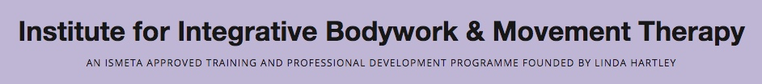

IBMT Module Registration Form & Payment Agreement
Module Name: | Somatic Psychology 2026 - 27
Your Name: |  | Pronouns:
Address:
Telephone:
Mobile:
E-mail:
In completing this form, I am giving my consent to my information being stored on the IBMT database. Further details can be seen in our Privacy Policy.
I am happy for my details to be shared on a Contact List. Yes/No
I am happy for my email address to be shared with the group if I want or can offer a lift Yes/No
IBMT Payment Policy. Please read carefully.

- A place on the Module is only secured once this form has been received along with a deposit or the full amount.
- Please note that deposits are non-refundable.
- Registrations and payment/arrangements to be completed 6 weeks before the start of each module.
- Cancellations less than 6 weeks before the start of the course must be paid for in full unless the place can be taken by someone from our waiting list.
- We regret there can be no refunds on any grounds once a course has begun. We are not liable for any travel or accommodation costs.
- Modules run subject to enough participants being registered. We reserve the right to cancel a module and any payments made will be refunded.
- Payment: By bank transfer in full or as a series of monthly standing orders set up on the first of the month. All payments must be received before the start of the last weekend of the module.
- When payments/refunds are made to/from international accounts, all banking fees to be met by the student.

I have read and agree with the IBMT Payment Policy above.
If I choose not to complete the training after it has started, I understand that the full fee will be due to be paid.

Signed:

Name: Date:

Payment arrangements:
Please indicate which option you are choosing – yes/no:

Yes/No
I have transferred the full fee of £1950

Date Payment made:
I have transferred the deposit of £300 (non-refundable) to secure my place and have arranged 10 monthly installments of £165 to cover the full fee, and payable on the 1st of the month, starting 1st Oct 2026 – 1st June 2027. I understand that any late payments will incur a £10 admin fee.
Payment Summary:
- Cost of Module: £1950 - £300 Deposit = £1650
- 10 Monthly Payments of £165

Date Deposit Paid:

Payment information:

On-line:

Account Name: IBMT Administration
Account Number: 28976868 Sort code: 30 90 39
IBAN (International Bank Account Number): GB84 LOYD 3090 3928 9768 68
Lloyds Bank BIC (Branch Identifier Code): LOYDGB21135

- Please use “Mod SP” as a reference. Include your initials in the reference if your name is not part of your bank account name and send an email to info@ibmt.co.uk giving details of the account that you are making payments.

Payments from Non-UK, Non-Sterling Accounts:

We recommend payment via wise.com. Please ensure we receive payment in Pounds.

For a video about setting up an account with wise: https://www.youtube.com/watch?v=qGmRv9SMxFw
For a video about sending money abroad with wise: https://www.youtube.com/watch?v=IZtLF0nhqFc

- If you make a bank transfer, please make sure that all transfer costs are covered, and the exact amount in £ sterling will be received (IF YOU ARE PAYING FROM A NON-UK ACCOUNT please add an additional bank charge of £7 to all payments over £100, £2 to all payments under £100).

Please sign and email this registration to info@ibmt.co.uk

