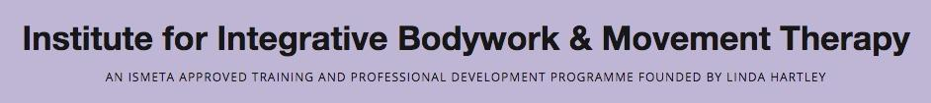
Final Record Sheet – IBMT Diploma Application
This form is to be filled in when you have completed all Modules and Course Requirements and submitted with your Case Study to Jane Okondo at info@ibmt.co.uk. Please keep a copy of all records.
Please include any make-up Tutorials or Seminars you have taken in place of missed days, with whom, and the number of hours.
Your Name:
1. Modules Completed:
Infant Movement Development: ………….hours completed out of 120 hours
Year …………….
Authentic Movement and Therapeutic Presence: ………….hours completed out of 72 hours
Year …………….
Embodied Anatomy & Movement Re-patterning: ………….hours completed out of 270 hours
Year …………….
Somatic Psychology: ………….hours completed out of 96 hours
Year …………….
Make-up Tutorials and Seminars: ………….hours
Total hours completed ………………. Out of 552 hours
2. Written papers completed:
Title:
Date handed in:
Title:
Date handed in:
Title:
Date handed in:
3. I have received at least 24 Individual Sessions. YES/NO
Please provide a list of dates and who those sessions were with here:

4. I have given and received at least 6 Client Sessions (with peers)
Date handed in written report:
5. Presentation
Title:
Date:
Presentation Written Statement Date submitted:
6. Case Study:
Date handed in:
Title:
7. Supervision during Case Study:
I have completed a minimum of 4 - 6 supervision sessions. Please provide a list of dates and Name of supervisor here:

8. Video session YouTube Link:

Signature ………………………………………………….

Date …………………………..

